Payroll Management System for Information Technology Company

Use-Case Specification: Delete Leave

Version 1.0

Revision History

|  |  |  |  |
| --- | --- | --- | --- |
| **Date** | **Version** | **Description** | **Author** |
| 15/12/2019 | 1.0 | Final | Quản Trong Tú |
|  |  |  |  |
|  |  |  |  |
|  |  |  |  |

Table of Contents

1. Use-Case Name 4

1.1 Brief Description 4

2. Flow of Events 4

2.1 Basic Flow 4

3. Special Requirements 5

4. Preconditions 5

5. Postconditions 5

6. Extension Points 5

Use-Case Specification: Delete Leave

# Use-Case Name

## Brief Description

This use case defines the steps of Deleting Leave for user who are working in company to store it in the database system. Employee can easily delete a exist leave for each user and themselves.

## Actor

Employee

# Flow of Events

## Basic Flow

The employee can delete their leave

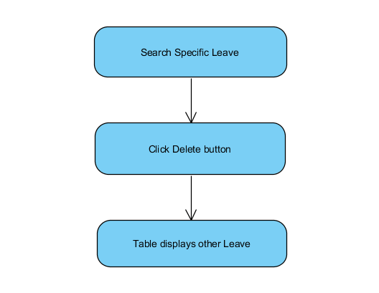

Basic Flow of Delete Leave Time

# Special Requirements

* Search user success.

# Preconditions

* Employee have to login into application and access Manage Leave view.

# Postconditions

Show Message status of this function.

# Extension Points

No extension points.